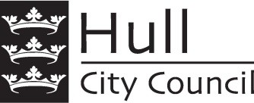

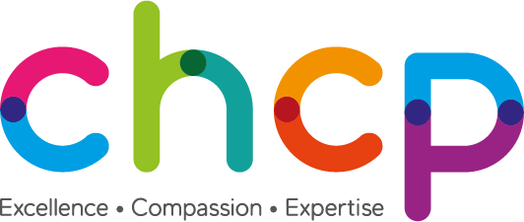
Dear Parent/Guardian

Measuring the Height and weight for children in Reception and Year 6
0-19 Integrated Public Health Team City Healthcare Partnership CIC Orchard Health Centre
210 Orchard Park Road
Hull HU69BX
Tel: 01482 336634/344301

Each year in England, school children in Reception and Year 6 have their height and weight checked at school as part of the National Child Measurement Programme. Height and weight measurements are used to calculate weight status. We collect this information because it is in the public interest to understand how many children are overweight, healthy weight or are underweight. Your child’s class will take part in this year’s programme.

The checks are carried out by trained school nurses or trained health care providers, in line with each school’s Covid-19 measures, which includes the team wearing PPE and any equipment being cleaned between each child.

Children are measured fully clothed, except for their coats and shoes, in a private space away from other pupils.

The information collected by us includes your child’s height and weight measurements together with their name, date of birth, gender, home address and postcode, NHS Number and ethnicity. This information about your child is needed because their age, gender, ethnicity and the place they live are known to affect their height and weight. Their name, date of birth and NHS Number is needed to link your child’s measurements to other information about your child. All this information is treated confidentially and held securely by us. It will not be shared with your child’s school or with other children.

Once completed we will send you your child’s measurements. You may also receive a follow up phone call from your School Health Team. The data may also be shared with our local council Healthy Lifestyles Service, who may contact you to offer free local support.

The information collected from all schools in the area will be gathered together and held securely by Hull City Council. We will store your child’s information on their local child health record on the child health information database and share it with their GP. No individual measurements will be given to school staff or other children, and all information will be treated confidentially. This data will also be submitted for national analysis, publication and shared with organisations such as NHS Digital and Public Health England (see reverse of this letter for more details) in a way that means individual children cannot be directly identified. All information will be treated confidentially.

If you are happy for your child to be weighed and measured you do not need to do anything OPTING YOUR CHILD OUT OF THE PROGRAMME
If you do not want your child to take part, please let your School Health Practitioner know by writing to them or telephoning them as soon as possible using the contact details at the top of this letter.

Children will not be made to participate if they don’t want to.

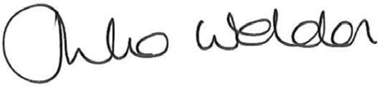
Yours sincerely

Julia Weldon Pauline Turner
Director of Public Health & Director of Children,
Deputy Chief Executive Young People & Family Services

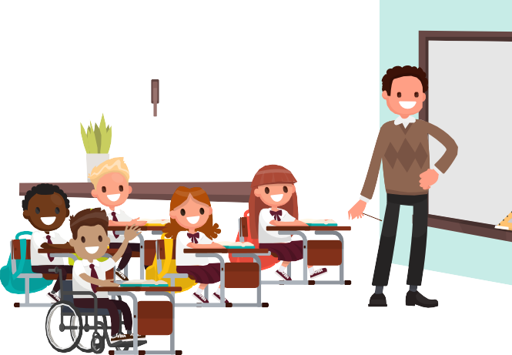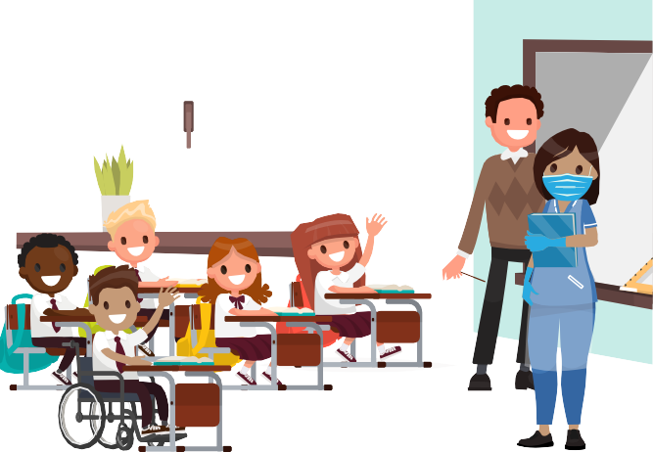

Today the school nurse is going to check how I’m growing and staying healthy.

The nurse asks me to stand next to a big ruler so she can see how tall I am.

I go to see the nurse and she says hello. She is wearing a mask and gloves to make sure I’m safe from any germs.
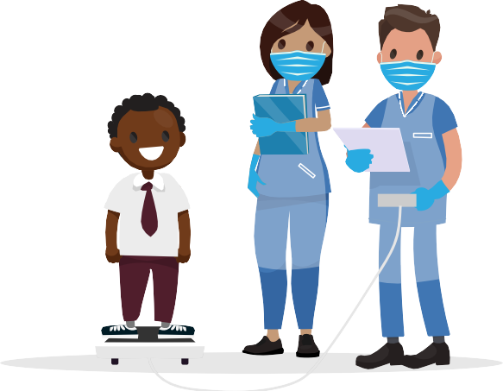
I stand on a little platform that tells the nurse how much I weigh.

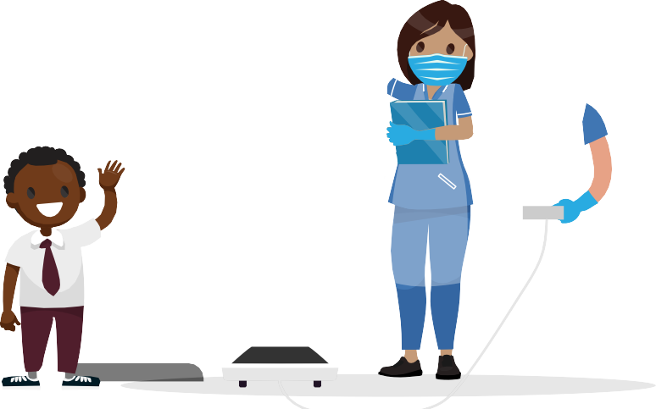

The nurse writes it all down and that’s it, back to class now!

chcpcic.org.uk

Details of how data is used / shared

All the information collected about your child will be sent by us to NHS Digital. NHS Digital is responsible for collecting health and care information to check how the NHS and social care services are doing, and to use this to improve the care provided to people across England.

The information collected about your child will also be shared by NHS Digital with Public Health England but in a de-personalised form only. This means Public Health England will not be able to identify your child. Public Health England is responsible for working to protect and improve the nation’s health.

Both NHS Digital and Public Health England will use the information from the National Child Measurement Programme to better understand numbers and trends in child weight and body mass index (BMI). This helps with the planning of services to support healthy lifestyles in your area. No information will ever be published by NHS Digital or Public Health England that identifies your child.

If your child was previously measured for the National Child Measurement Programme, NHS Digital may link your child’s current and previous height and weight measurements. It may also link their measurements with other information it holds about your child such as their dental survey results or the reasons for any visits they may have made to hospital. Linking your child’s information in this way helps better understand how and why the weight status of children is changing.

De-personalised information from the National Child Measurement Programme may also be shared by NHS Digital with other organisations, such as universities. This is to help improve health, care and services through research and planning. This information cannot be used to identify your child, and NHS Digital only ever shares information for research with the approval of an independent group of experts.

Further information

For details of how Hull City Council Public health process personal information please refer to the details on this page of our website - http://www.hull.gov.uk/help/service-or-project-specific-privacy-notices

Alternatively, you can request a copy by calling 01482 300300

Further information about the National Child Measurement Programme can be found at https://www.nhs.uk/live- well/healthy-weight/national-child-measurement-programme

Information and fun ideas to help your kids stay healthy can be found at https://www.nhs.uk/change4life

Information about how NHS Digital and Public Health England collect and use information can be
Found at https://digital.nhs.uk/about-nhs-digital/our-work/keeping-patient-data-safe/how-we-look-after-your-health-and- care-information

