Humber Education Trust

Special educational needs policy

This policy was reviewed by the HET Trustees: September 2023

Graeme Brook Chair of Trustees
This policy will be reviewed annually on or before: September 2024

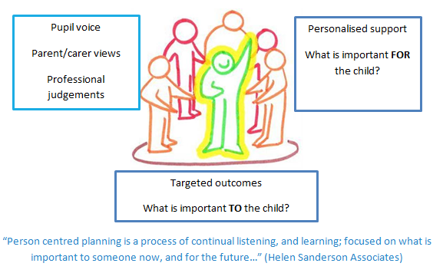

- Aims

  - All schools within the Trust share common values and an ethos that adheres to inclusive principles. The schools in the trust work collaboratively to endeavour to meet the needs of all learners in the trust.
  - To cater for the broad range of needs the trust recognises the benefits of following a person-centred approach, working collaboratively and in employing an inquiry mind-set to identify and implement provision to address a pupil’s learning needs. Our support for all children within our care extends to those children with additional needs that require assistance to help them fulfil their potential.
  - Each school within Humber Education Trust shall ensure that:
  - the special educational needs of pupils will be addressed and pupils will not be labelled or disadvantaged by any policy or procedure operated within the Trust;
  - it works in partnership with parents and appropriate external agencies to support students with special educational needs and will use its best endeavours ensure that appropriate provision is secured for any student with special educational needs in order to achieve agreed outcomes;
  - it has a Special Educational Needs Co-ordinator (SENCO). The SENCO will maintain and regularly review the SEN record held in respective of an individual pupil and co-ordinate support. However, it will be the responsibility of all staff to support individual pupils, to implement strategies suggested by the SENCO and generally be responsible for ensuring that pupils receive provision appropriate to their needs and agreed outcomes; and
  - children and young people with SEN engage in the activities of the school alongside pupils who do not have SEN
  - All support provided and decisions taken have regard to these general principles as well as the legal framework set out in the Children & Families Act 2014, the SEND Regulations 2014 and the SEND Code of Practice 2015.
- Definitions
  - Under the Children & Families Act 2014, a child/young person will have SEN if they have a learning difficulty or disability which calls for special educational provision to be made for them.
  - A Child or Young Person will have a learning difficulty or disability if they have:
  - A significantly greater difficulty in learning than the majority of others of the same age; or
  - A disability that prevents or hinders them from making use of facilities that are generally provided for others of the same age in mainstream schools in England.
  - Special Educational Provision is education or training that is additional to, or different from, that made generally for other children/young people of the same age by mainstream schools
- Roles & Responsibilities
  - The implementation of this policy will be monitored by the Trust Board and remain under constant review by the Headteacher/Principal.
  - Each school will appoint a governor with responsibility for SEN. The SEN Governor will raise SEN issues at governing board meetings; monitor the quality and effectiveness of SEN provision within the school and work with designated senior leaders to develop the SEN policy and provision.
  - The Principal/Head Teacher will work with the SENCO and SEN Governor to develop the SEN policy and provision within the school. The Principal/Head Teacher has overall responsibility for the provision and progress of learners with SEND.
  - The SENCO will co-ordinate the school’s approach to SEND provision and will undertake those duties set out in chapter 6 of the SEND Code of Practice 2015.
  - Class teachers are responsible for the progress and development of every pupil in their class and will work with the SENCO and TAs to ensure the “assess plan do review” cycle is appropriately implemented to support any pupil student with SEND.
  - The school will work in partnership with pupils, teachers, parents and, where appropriate, other external agencies to ensure that individual learning needs are addressed within the context of the school curriculum.
  - Parents of SEN pupils will be able to discuss the needs of their child with their child’s class teacher or the SENCO.
- Identification & Assessment of SEN
  - Humber Education Trust is committed to the early identification and support of all pupils in the trust. Schools in the trust have a clearly defined graduated response which takes account of quality first teaching, interventions and further provision.

Our graduated response:

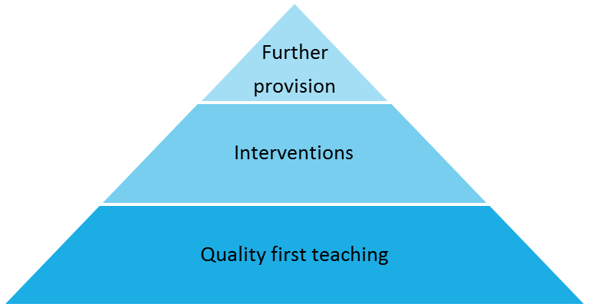
  - The professional judgement of practitioners in the school, alongside the views and wishes of pupils and parents plays an important role in the assessment and review of pupils’ needs. Where required we liaise with other professionals including those from health, social work or voluntary sectors to provide additional assessment information.
  - Information about previous special educational needs will usually accompany pupils upon entry to the school and this will be used by the SENCO to make sure appropriate provision is continued.
  - This information is collated from the transfer of school files from the previous school or early years setting and during transition meetings which are held with all the feeder schools or early years settings, in the summer term, before students start at the school. If necessary a strategy sheet will be drawn up for each student with SEN.
  - Ongoing identification is also completed alongside the school reporting process as data is collected and analysed in all subject areas by the Headteacher/Principal. If a pupil has not made expected progress then interventions will be put in place regardless of need. If a member of staff identifies a pupil whose special educational needs are not met by the normal differentiated programme of study, then the class teacher will work with the pupil setting clear targets and providing greater differentiation. If the situation improves then no further action is needed. If there is no improvement the SENCO will be informed.
  - At this point information will be gathered. The class teacher will inform the parents about the issue and there will be consultation and discussion around the proposed additional support for the pupil. Parents, and the pupil where appropriate, will be involved in sharing information and agreeing outcomes. It will be decided whether it is appropriate to further monitor the student. A strategy sheet will be drawn up by the SEN team with copies shared with all staff concerned with the pupil’s progress.
  - If a parent/carer refers their child to the school as they believe their child has special educational needs they should contact the SENCO, who will undertake investigations and appropriate assessments (with input from the relevant teachers) to see if they are achieving expected levels of progress. If the pupil is not making appropriate levels of progress then internal support will be implemented in accordance with paragraphs above.
  - In all cases, where internal support is not effective in supporting the pupil, a referral to the Educational Psychologist or other relevant specialist will be completed with the parents’ knowledge and information and strategies for support shared with all staff.
  - If there are no concerns regarding the pupils’ academic progress then the school will ensure appropriate differentiation continues in the classroom and interventions are put in place if appropriate.
  - Contact details for professionals who are able to assess will be provided for parents/carers so they can consider a private assessment. Whenever special educational provision is being made, parents and students will be involved in developing and reviewing support plans/strategies.
  - All staff teaching pupils on the SEN record will be made aware of the individual needs. Leaders and the Special Needs team will help teachers when required to develop techniques to support differentiation and ensure that appropriate resources are available as part of the school’s Professional Development Programme.
- Reviewing
  - All pupils regardless of needs are set targets. Data collated during the school reporting process is analysed and strategies are put in place to support that that are not achieving as expected. All SEN interventions delivered outside the classroom have Specific, Measurable, Achievable Targets (SMART) set to ensure that progress is made. These are recorded using Individual Education Plans (IEPs) and are monitored and reviewed against a time frame, agreed within the plan. If expected progress is not made then the SENCO may refer to a specialist services such as an Educational Psychologist.
  - If a pupil has an Educational Health Care Plan an annual review is held in accordance with legal requirements.
  - If, as a result of appropriate progress, a pupil is removed from the SEN record. The pupil will continue to be monitored through the school’s structured reporting programme by the Headteacher/Principal.
- Policy Links
This policy should be read in conjunction with:
  - SEN Information Report (updated annually)
  - Equality Policy & Objectives
  - Accessibility Plan

Arrangements for Co-ordinating Provision for Children with Special Educational Needs.

Roles and Responsibilities at
Clifton Primary School 2023/2024

To be reviewed September 2024

- The Governing Body
The Governing Body in each Humber Education Trust school, in co-operation with the HET Governing Body and the HET CEO and each school’s Head teacher/Head of school, determine the school’s general policy and approach to provision for children with SEND. The Governing Body must report to parents annually on the school’s policy on SEND. The Governing Body will nominate one governor with responsibility for SEND. The Governing Body of maintained mainstream schools must ensure that there is a qualified teacher designated as SENDCO for the school. The SEN Governor will liaise regularly with the SENDCO and report back to the School Committees.
- The Head Teacher
The Head teacher has responsibility for the day-to-day management of all aspects of the school’s work, including provision for children with SEND. The Head Teacher should keep the Governing Board fully informed and also work closely with the SENDCO.
- The SENDCO
The SENDCO at Clifton Primary School is:
Mrs Sarah Middleton-Wood
She can be contacted via admin@clifton.het.academy
The SENDCO has an important role in advising the Head teacher and Governing Body, in determining the strategic development of SEND policy and provision in the school and is a member of the Management Team. The SENDCO has day-to-day responsibility for the operation of SEND policy and coordination of specific provision made to support individual pupils with SEND, including those who have EHC plans. The SENDCO provides professional guidance to colleagues and works closely with staff, parents and other agencies. The SENDCO should be aware of the provision in the Local Offer and be able to work with professionals providing a support role to families to ensure that pupils with SEND receive appropriate support and high quality teaching.

Key responsibilities are:
• Overseeing the day-to-day operation of the school’s SEND policy
• Co-ordinating provision for children with SEND
• Liaising with the relevant Designated Teacher where a looked after pupil has SEND
• Advising on the graduated approach to providing SEND support
• Advising on the deployment of the school’s delegated budget and other resources to meet pupils’ needs effectively
• Liaising with parents of pupils with SEND
• Liaising with early years’ providers, other schools, educational psychologists, health and social care professionals, and independent or voluntary bodies
• Being the key point of contact with external agencies, especially the local authority and its support services
• Liaising with potential next providers of education to ensure a pupil and their parents are informed about options and a smooth transition is planned
• Working with the Head teacher and school governors to ensure that the school meets its responsibilities under the Equality Act (2010) with regard to reasonable adjustments and access arrangements
• Ensuring that the school keeps the records of all pupils with SEND up to date
• Overseeing the records of all children with SEND.
• Contributing to the in-service training of staff.

4. The Teachers
Staff within the trust receive a high level of ongoing training and demonstrate a high degree of expertise in their care, support and teaching of pupils with a broad range of needs. This document highlights the importance of correct, efficient, fluent use of teaching strategies, tailored to support individual pupils.
The trust takes action to remove barriers to learning and actively promotes staff to employ an enquiring mind-set when working with our pupils. The Humber Education Trust recognises the importance of finding out about how our pupils learn and making valued professional judgments, so that we may best support their learning.

Teachers are responsible and accountable for:
• The progress and development of the pupils in their class, including where pupils access support from teaching assistants or specialist staff
• High quality teaching which is differentiated for individual pupils. All teachers are aware of the procedures for identifying, assessing and making provision for pupils with SEND, and are actively involved in the review process.

5. The Achievement Support Assistants (ASAs)
The ASAs work with the class teacher and SENDCO in providing support for children with Special Educational Needs across the school, maintaining records of the children they work with, and attending reviews and meetings as requested.
6. Pupil Participation
The Humber Education trust places significant importance on pupils’ capacity to communicate in order to stay safe, express their views and understand information. The trust ascribes to the mantra ‘no decision about me, without me’.
Pupils with SEND often have a unique knowledge of their own needs and circumstances, and their own views about what sort of support they would like to help them make the most of their education. They will be encouraged to participate in the decision-making processes, wherever possible, including the setting of learning outcomes and contributing to their outcomes. This will be achieved through a variety of different approaches as appropriate to the age of the child.
These include:
- Pupil interviews
- Questionnaires
- Self-evaluation (pictures, written answers)
- Pupil set outcomes
- The Role of Parents of Pupils with SEND
Humber Education Trust recognises the significant contribution parents can make to the education of their child and as such the trust seeks to work in full partnership with parents and carers. The Code of Practice (2015) emphasises the importance of excellent partnerships between the school and the views, wishes and feelings of the child and their parents. This is what underpins the principles of the Code of Practice (2015), which are designed to support:

• The participation of children, their parents and young people in decision making
• The early identification of children and young people’s needs and early intervention to support them
• Greater choice and control for young people and parents over support
• Collaboration between education, health and social care services to provide support
• High quality provision to meet the needs of children and young people with SEND
• A focus on inclusive practice and removing barriers to learning
• Successful preparation for adulthood, including independent living and employment
The school endeavours to foster positive working relationships with parents, provides user-friendly information and strives to ensure that they understand the procedures and are aware of how to access advice and support. Parents will be supported and enabled to:
• Recognise and fulfil their responsibilities as parents and play an active and valued role in their child’s education.
• Have knowledge of their child’s entitlement within the SEND framework.
• Make their views known about how their child is educated.
• Have access to information, advice and support during assessment and any related decision making processes about Special Educational provision.
We encourage active participation of parents by providing guidance on how they can support their child’s learning at home. We value the contribution that parents make and the critical role they play in their child’s education.
All parents of children with SEND have access to the SEN Information Report and Local Offer, which gives additional information about Special Educational Needs and Disability. This also provides information about the Parent Partnership service. This is a free service, which supports parents of children with SEND. Links to the SEN Information Report and The Local Offer can be found in the SEND section of each school’s website.
Additional information and/or leaflets are available from the SENDCO on request. Parents are encouraged to contact the child’s class teacher and/or the SENDCO as needed either by telephone or appointment.

- Pupils with Medical Needs
Pupils with medical needs will be provided with a detailed Health Care Plan, compiled by the school in partnership with parents and, if appropriate, the pupil themselves.

Staff who administer medicine complete training and are approved by the school as competent.

All medicine administration procedures adhere to the Trust’s Policy Supporting Pupils Medical Conditions in School & Administration of Medicines and DfE guidelines included within Supporting pupils at school with medical conditions (DfE) 2014

This policy complies with the statutory requirement laid out in the SEND Code of Practice 0-25 (September 2014) 3.65 and has been written with reference to the following guidance and documents:

• Equality Act 2010: advice for schools DFE February 2013
• The Children and Families Act 2014
• The SEND Code of Practice 0-25 2014
• Schools SEN Information Report Regulations (2014)
• Statutory Guidance on Supporting Pupils in School with Medical Conditions April 2014
• The National Curriculum in England: Key stage 1 & 2 Framework (December 2014)
• Teaching Standards (2012)

