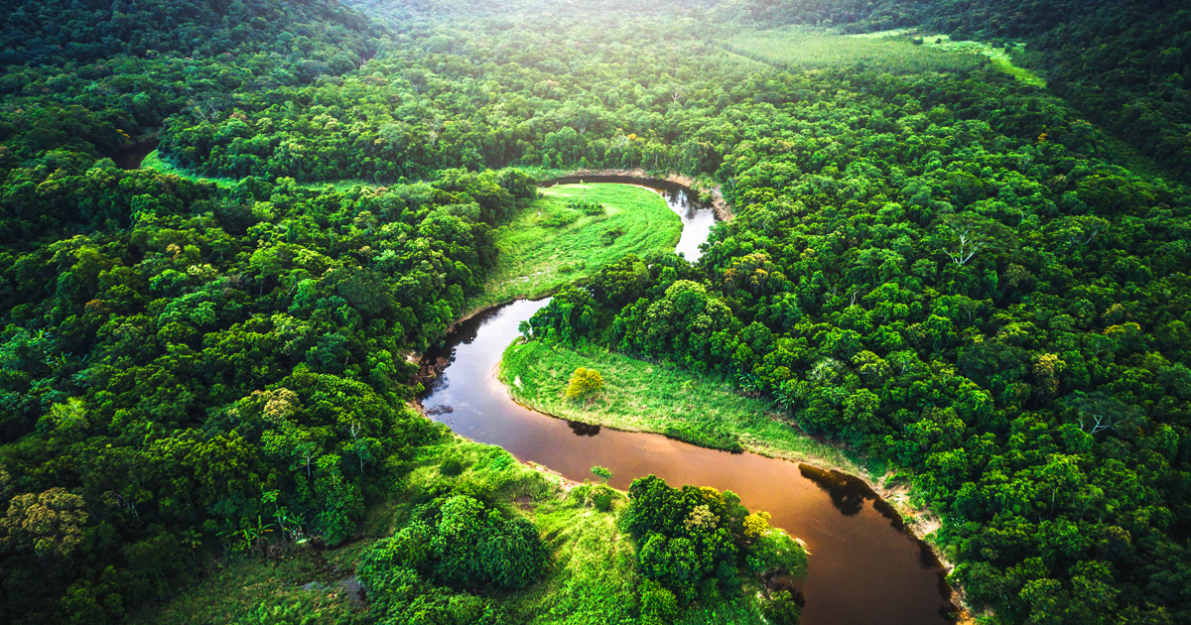

**Year 4 Summer Term: Rivers and the Water Cycle**

**Enrichment: Yorkshire Water Learning Lab**

**Science**

**As scientists, we will learn all about the human teeth and the digestion system. We will learn about the different states of matter and how these can change when heated or cooled.**



**Maths**

**As mathematicians, we will continue to learn about multiplication and division in preparation for the MTC. We will develop our understanding of fractions and decimals.**

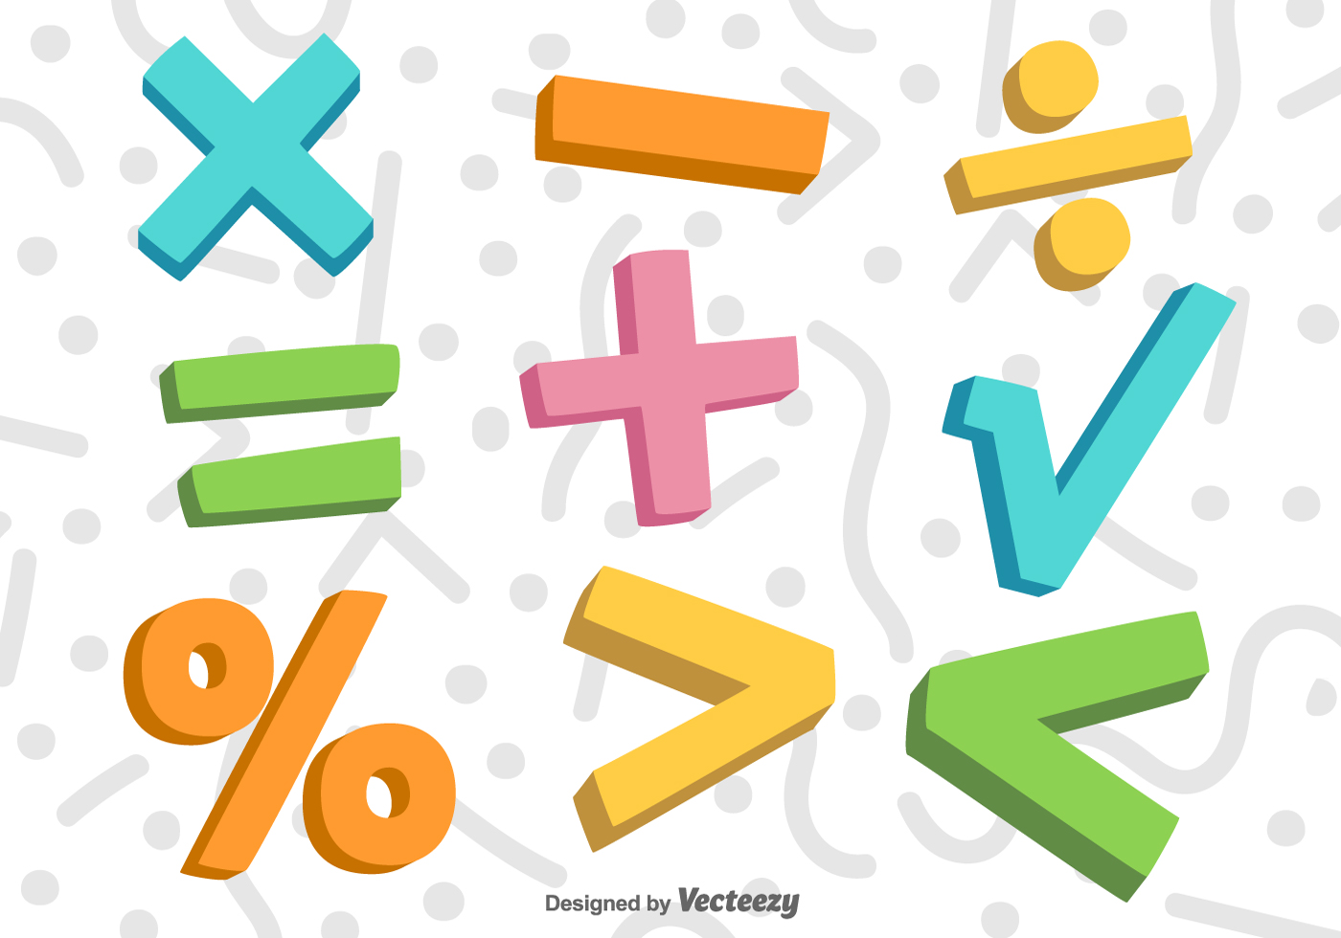

**English**

**This term, we will use these texts to inspire and support our learning. We will develop our comprehension and inference skills and develop our writing using a range of genres.**

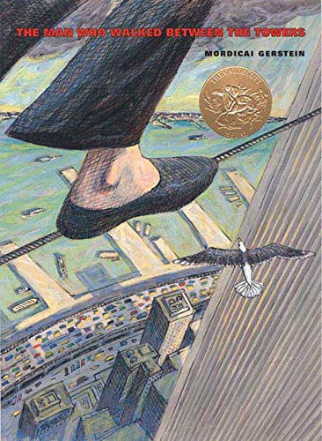 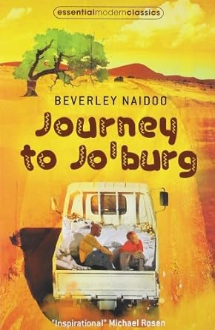

**Art**

**As artists, we will be looking at the work of David Hockney and how he uses colour and textures. We will then create our own landscape paintings using these skills.**

**History**

**As historians, we will learn about how bridges were developed and how these have changed over time. We will focus on the Humber Bridge and learn about how its development impacted on our local area.**

**Geography**

**As geographers, we will learn about the location of major rivers of the UK and the World. We will learn about how rivers are formed and their importance.**

**D&T**

**As design technologist, we will combine our scientific knowledge on electricity to create a lighthouse using Crumble kits.**

**PE**

**As sports people, we will develop our ball skills and apply them to a variety of ball games including netball and cricket.**

**RSHE**

**Jigsaw themes are: Goals and Dreams and Healthy Me. We will learn about how to deal with our emotions and feelings. We will also learn about friendships.**

**Music**

**As musicians, we will work with Hull Music Service to sing and perform. We will learn about dynamics and how to play an instrument and perform.**

|  |
| --- |
|  |

|  |
| --- |
|  |

**our voices in**

**RE**

**The RE theme is People Who Inspire Us. We will develop our understanding of why and how a person of faith devotes themselves to a worthwhile cause.**

**Computing**

**In computing, we will learn how to programme a sprite to create shapes and how we can use debugging. We will look at how data is collected using a data logger.**

*shape*