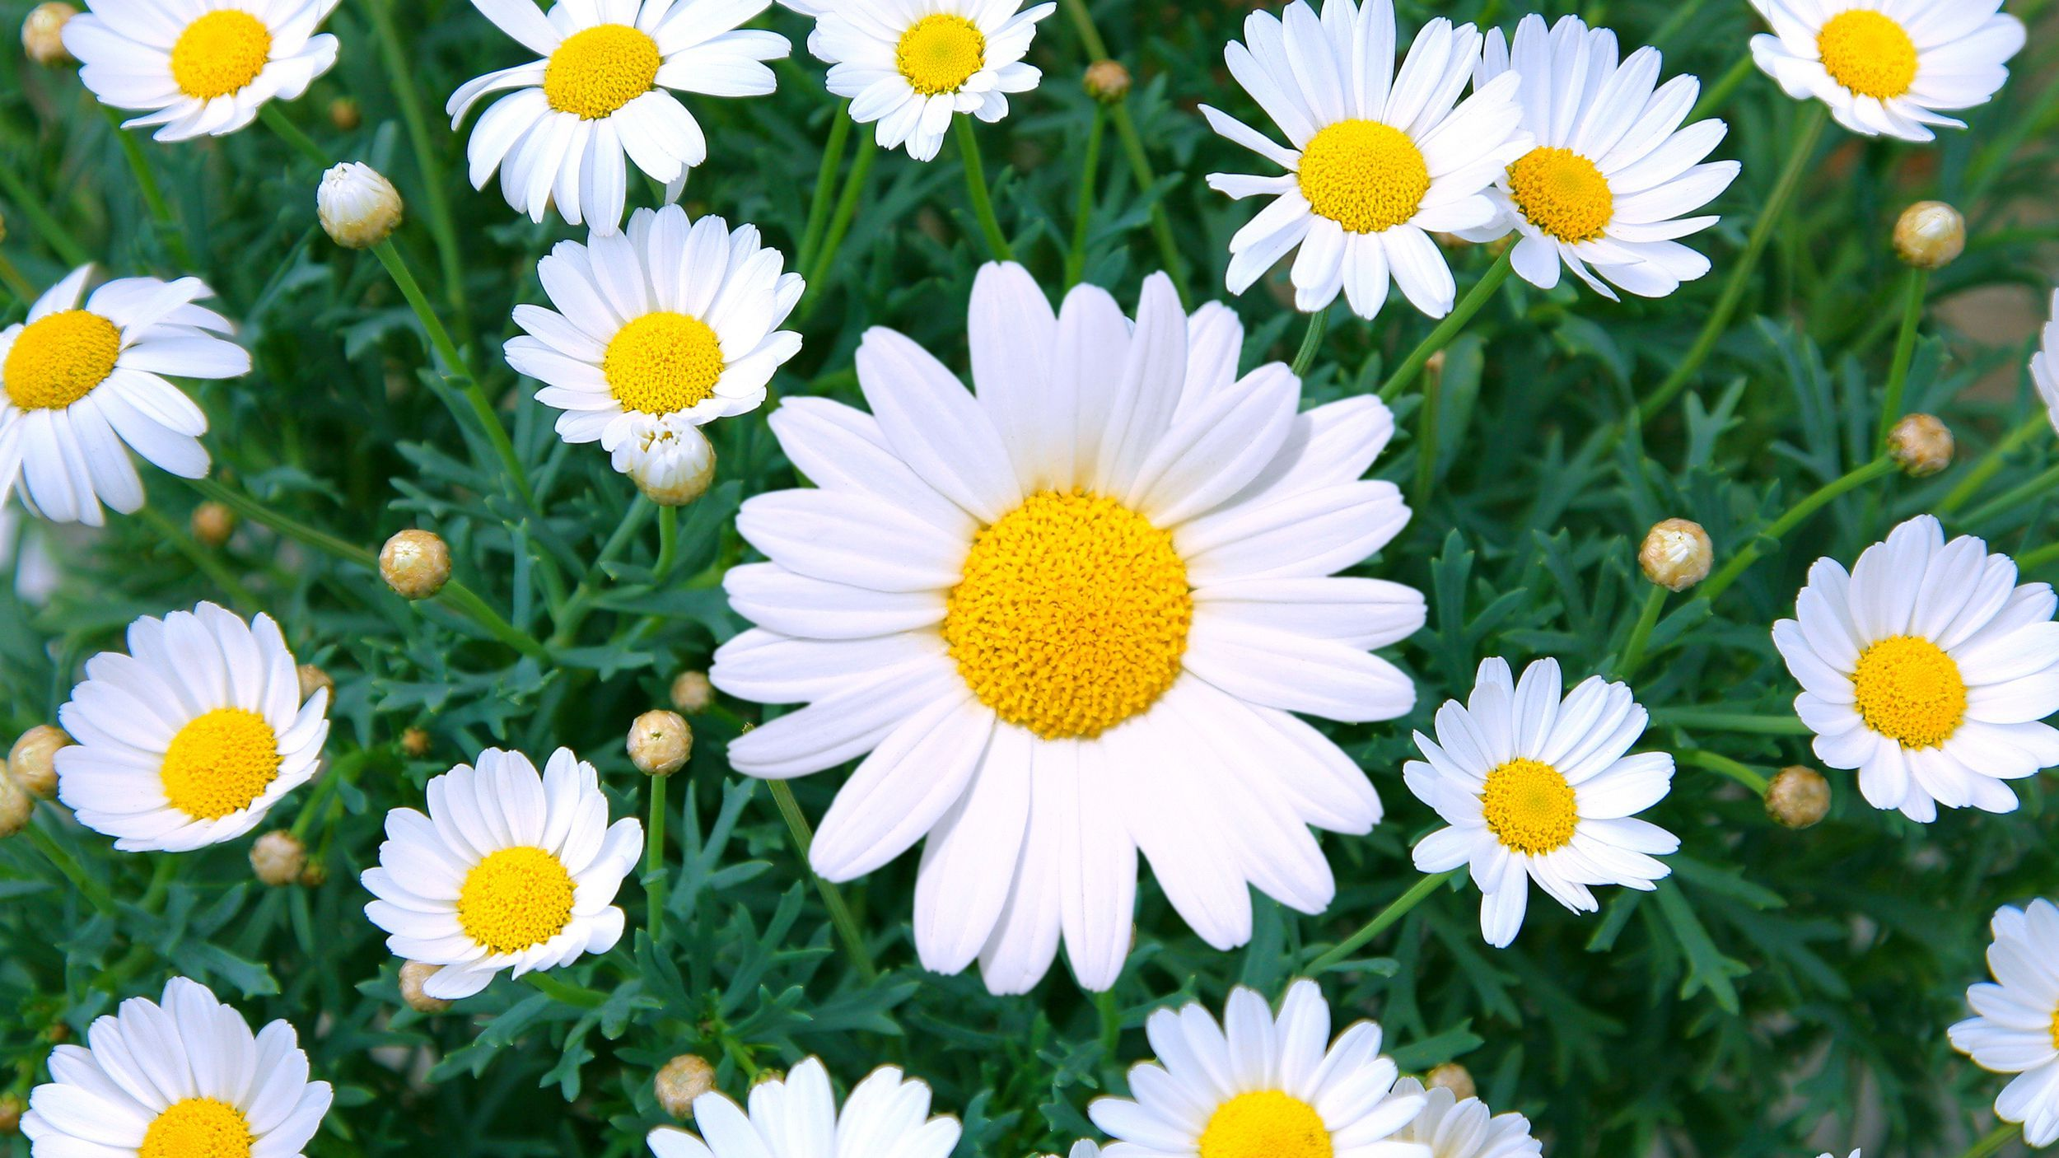

**Year 1 Summer Term**

**Science**

**As scientists we will learn about the life cycle of plants.**

**We will be planting our own plants and learning how to keep them alive.**

**Maths**

**As mathematicians we will learn about numbers to 100 and develop our skills of addition and subtraction. We will also be learning about weight, capacity, measure and shape.**

**English**

**This term we will use these texts to support our learning. We will be developing our knowledge on suffixes, prefixes, plurals and writing for different purposes.**

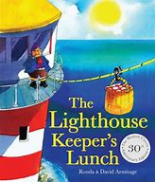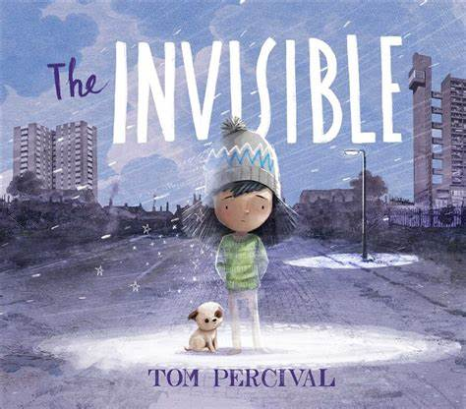

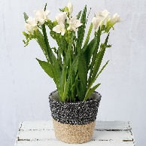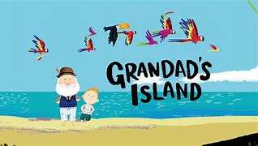

**Art**

**As artists we will appreciate the work of Andy Goldsworthy before creating our own nature inspired artwork and still life drawings.**

**History**

**As a historian we will learn about Grace Darling and looking at holidays in the past.**

**Geography**

**As a geographer we will develop our knowledge about the four countries of the United Kingdom and how weather is different around the world.**

**D&T**

**As design technologists we will investigate, design, make and review a fruit salad and learn about eating healthily.**

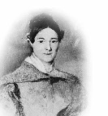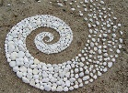

**Music**

**As musicians we will be having fun with improvisation.**

**PE**

**As sports people we will learn and practice athletics including running, jumping and racing.**

**RSHE**

**The Jigsaw theme is: Changes.**

**RE**

**The RE theme is special places of worship and communities.**

**Computing**

**In computing we will use skills we will be learning about how to stay safe online and how to retrieve information from the internet.**

