

**Year 6 Summer Term: Enrichment Activities – day trip to London and 2 night Raywell residential.**

**Science**

**As scientists, we will learn about: Living things and their habitats; and Evolution and Inheritance.**

**We will conduct an investigation into how fungi (mould) grows on bread.**

**We will learn about the scientist Carl Linnaeus, and how he developed the classification system of living things.**

**Maths**

**Supported by the White Rose Scheme of work, the focus of our learning will be geometry and measurement. We will consolidate our understanding of number and use this to work through algebraic calculations.**

**AS mathematicians, we will continue to develop our fluency when calculating.**

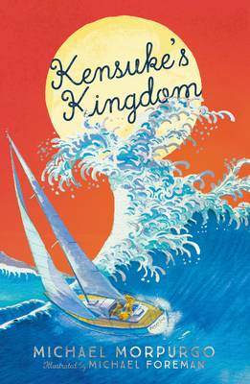**English**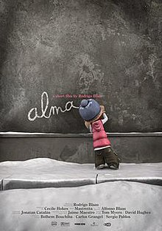

**This term we will use these texts and animations to support our learning. We will write using a range of genres to consolidate our understanding of all punctuation taught across KS2. We will continue to develop our comprehension skills using the text to support our understanding.**

**Art**

**As artists, we will learn about the artist Vincent Van Gogh. We will look at how mood and feeling are created with the use of hot, cold and harmonious colours, and with tonal contrast. We will paint our own landscapes using a specific colour palette.**

**History**

**As historians, we will debate which change has had the biggest impact on how we live today.  We will investigate the Industrial Revolution with a particular focus on farming and agriculture.**

**Geography**

**As geographers, we will locate the position and understand the significance of longitude, latitude, time zones. We will interpret maps and aerial photographs to develop our understanding of the world.**

**D&T**

**Or D&T focus Food Technology – Bread.**

**We will adapt a recipe by adding or substituting ingredients whilst cooking on a budget.**

**Religion and World Views**

**The RE theme this term is Hopes and Visions. We will consider the teachings of different faiths the impact these have on faith members using our key question- What is Life About?**

**PE**

**As sports people we will continue to develop our athletic skills and use these to compete against each other in a range of mini events.**

**Computing**

**In computing, we will plan, develop and evaluate 3D computer models of physical objects. We will design and code a project that captures inputs form a physical device.**

**Music**

**As musicians, we will learn body percussion skills to create music in a practical way using Connect It by Anna Meridith.**

**RSHE**

**Jigsaw themes this term are: Changing Me and Healthy Me. We will be receiving a talk about ‘Growing-Up’, and we will discuss relationships.**