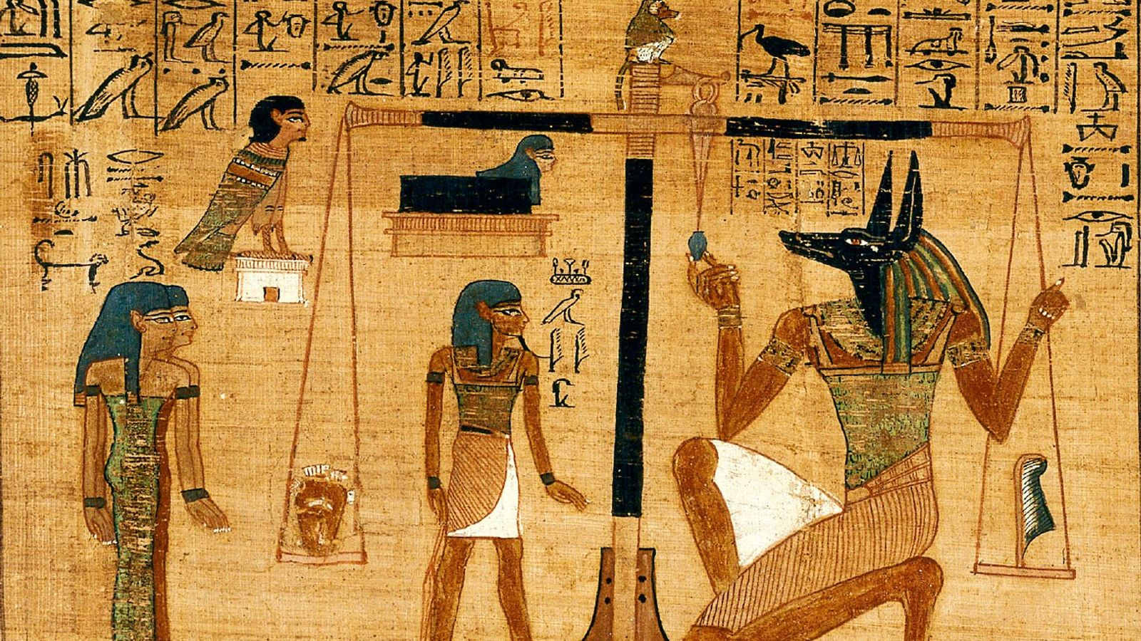

**Year 4 Summer Term:**

**Science**

**As scientists, we will learn all about the states of matter and investigate how these may change. We then develop our knowledge about living things and their habitats and how the environment can endanger living things.**

**Maths**

**As mathematicians, we will learn about a range of measurements including money, and time. We will learn about a range of shapes and their properties.**

**English**

**This term, we will use these texts to inspire and support our learning. We will develop our comprehension and inference skills and develop our writing using a range of genres.**

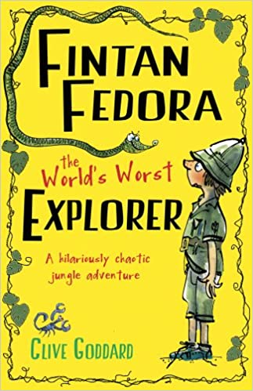 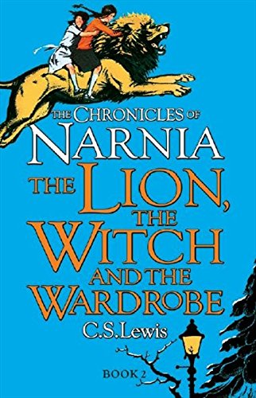

|  |  |  |  |  |
| --- | --- | --- | --- | --- |
| Mason | Carter | Mason | Carter | Mason |
| Carter | Mason | Carter | Mason | Carter |

**Art**

**As artists, we will be looking at the work of William Morris. We will develop our sculpturing techniques and create a Canopic jar using mouldable materials.**

**History**

**As historians, we will learn about when and how the Ancient Egyptians live. We will use our historical knowledge to compare this to periods in history we have learned about.**

**Geography**

**As geographers, we will learn about the location of biomes focussing on the location of the Sahara Desert. We will learn about the hemispheres and how the weather is different in each of these.**

**D&T**

**As design technologist, we will investigate which ingredients can be combined to make a healthy alternative to a traditional dish.**

**PE**

**As sports people, we will develop our athletic skills. We will then develop our understanding of team work and how to communicate effectively.**

**RSHE**

**Jigsaw themes are: Relationships and Changing me. We will learn about how to deal with changes to our bodies and emotions.**

**Music**

**As musicians, we will work with Hull Music Service to sing and perform. We will learn about dynamics and how to play an instrument and perform to an audience.**

|  |
| --- |
|  |

|  |
| --- |
|  |

**our voices in**

**RE**

**The RE theme is Our World. We will consider what an ultimate question is and what different faiths believe.**

**Computing**

**In computing, we will learn how to use search engines effectively, whilst keeping ourselves safe online.**