**Year 5 Summer Term: It’s Time for Africa!**

**Planned Enrichment Activities – Visit to Sewerby Hall and Gardens, A visit from a sculptor**

**Science**

As scientists we will learn about Earth and Space, and Forces. In Earth and Space, we will describe the movement of the Earth, and other planets, relative to the Sun. In Forces, we will explain the force of gravity acting between the Earth and falling objects. We will find out about famous scientists Galileo Galilei and Sir Isaac Newton.

**Maths**

As mathematicians we will develop our skills using decimals and percentages. In geometry, we will learn how to estimate, measure and draw a range of angles. In measure, we will learn how to convert between different units of metric measure.

**English**

This term we will use these texts to support our learning. We will develop our comprehension skills and write using a range of genres.

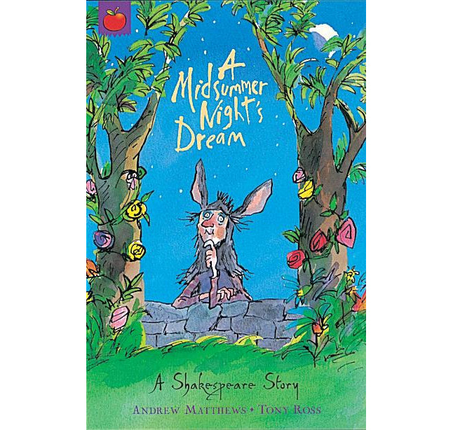 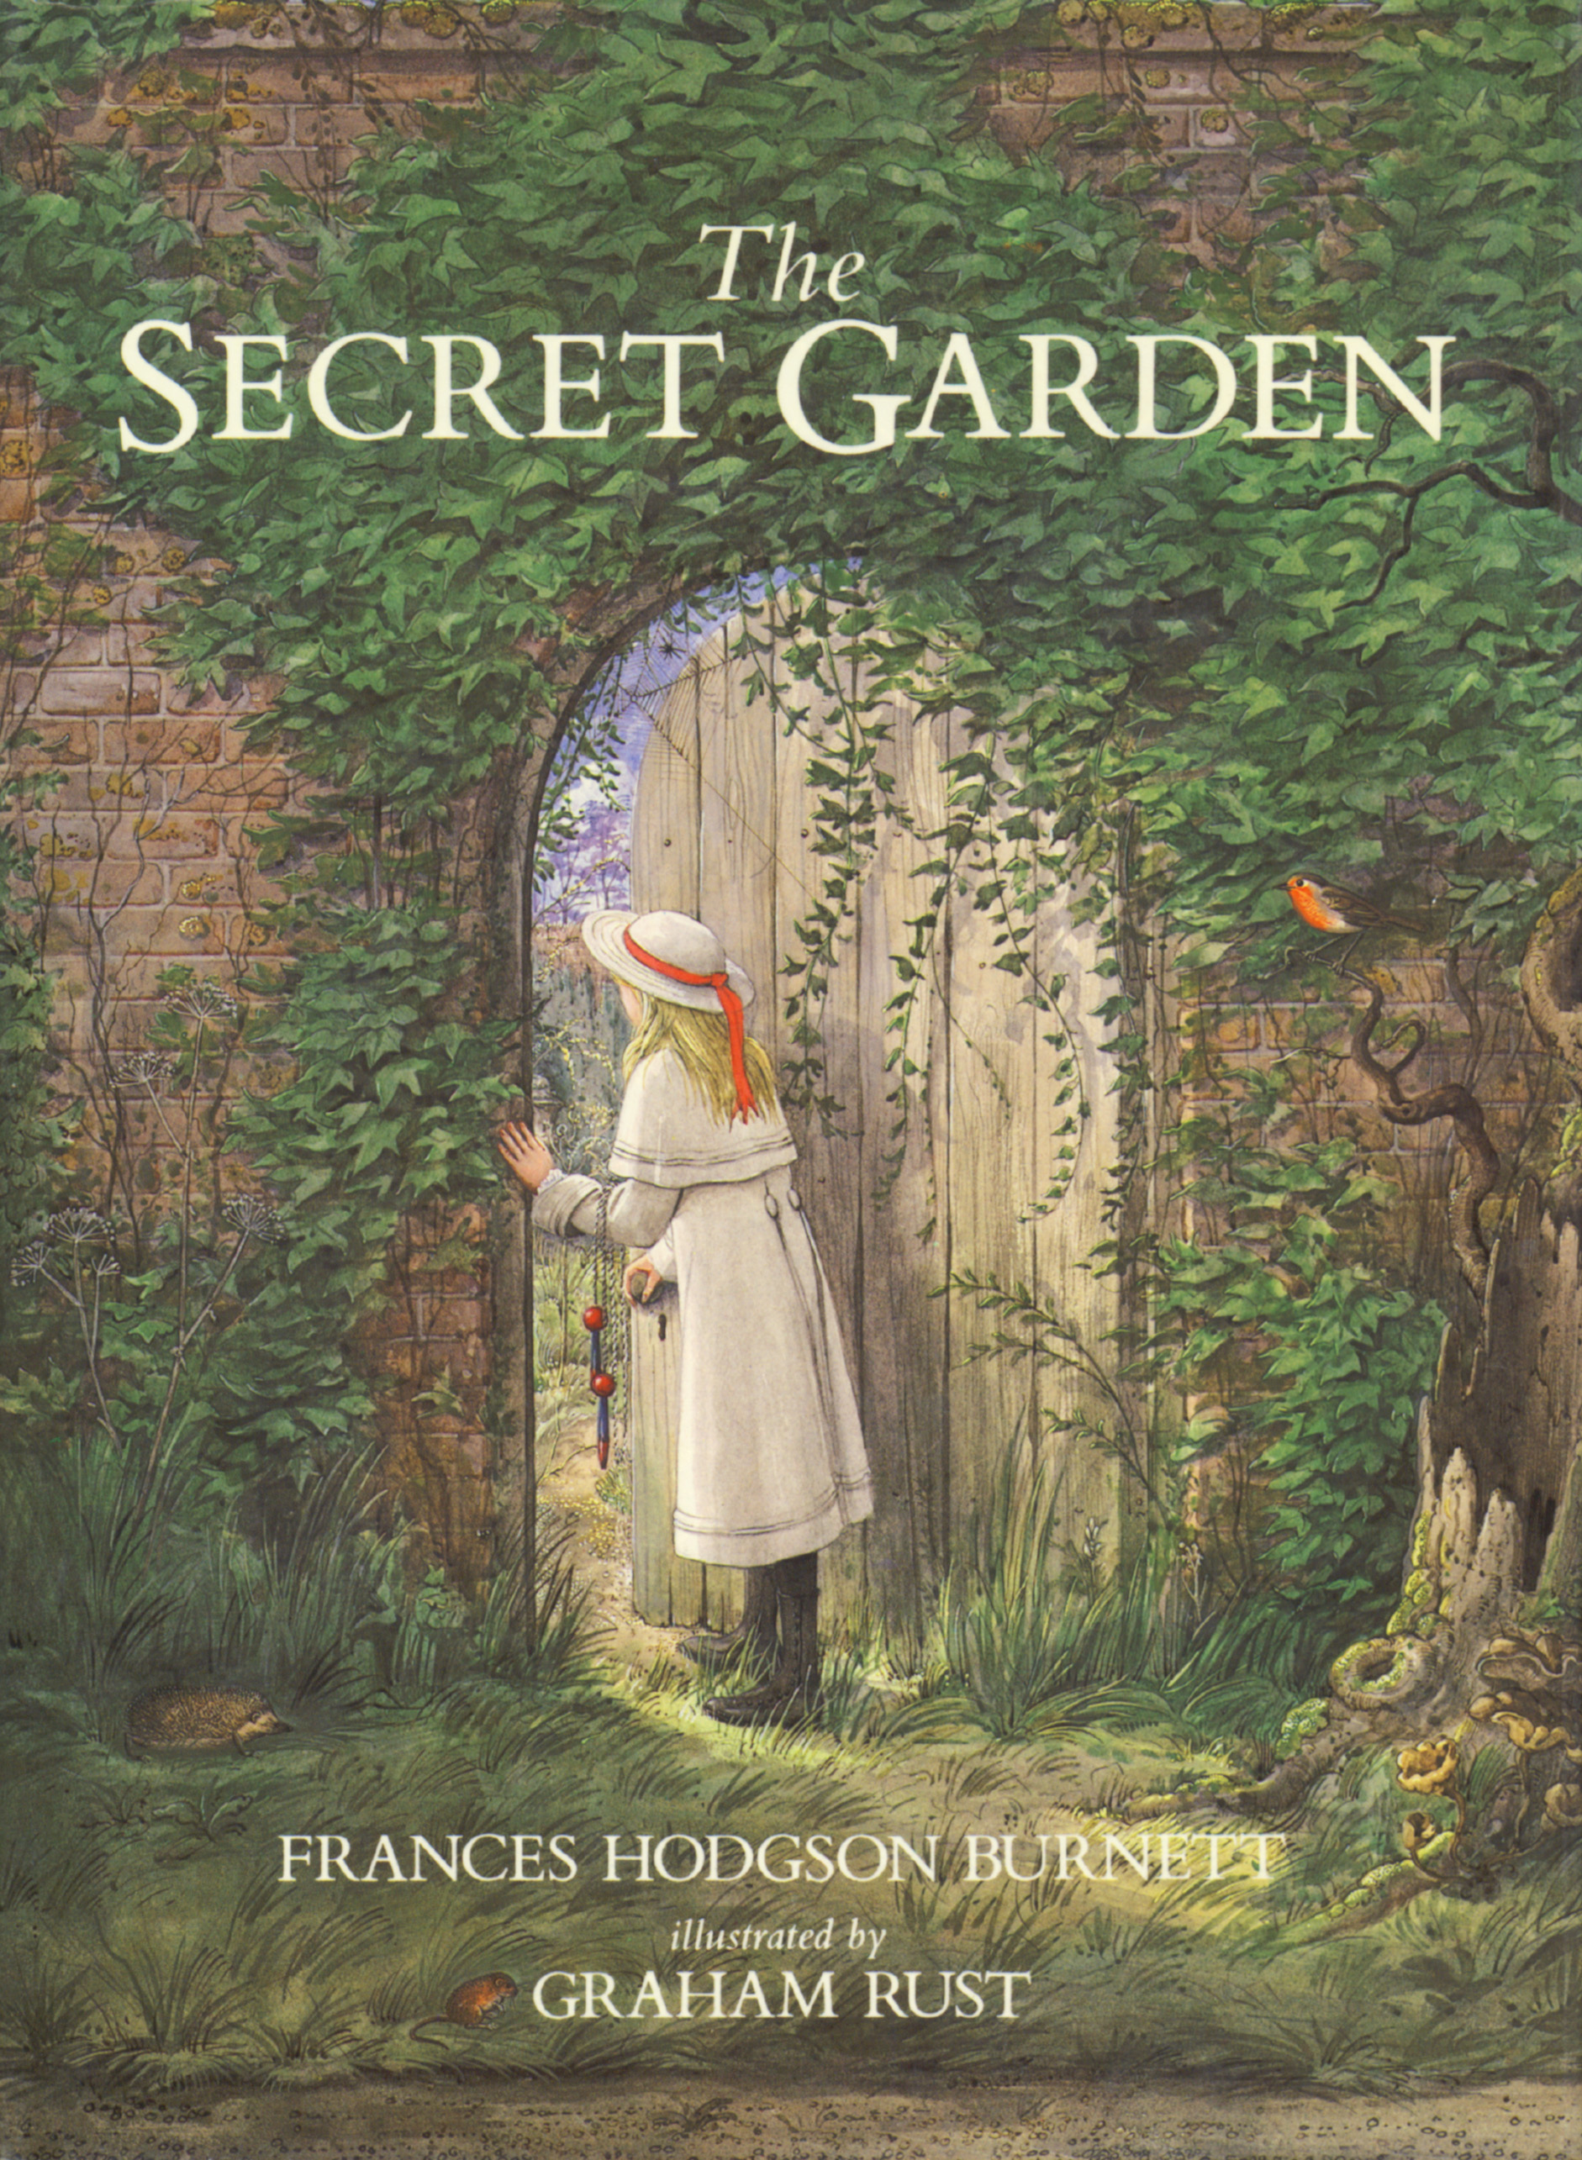

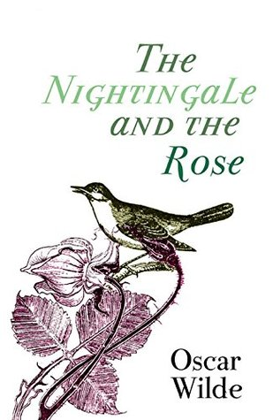

**History**

As a historian we will learn about the Ancient Kingdom of Benin in modern day Western Africa. We will look at the connection between the UK and Benin and the current debate about the ownership of the famous Benin Bronzes.

**Geography**

As geographers, we will look at how leisure facilities have changed over time and what facilities are now available to children.

Art

As artists we will appreciate the techniques used by sculptor Augusta Savage. We will look at the Ancient Benin Bronzes and create replicas by moulding clay.

**D&T**

As design technologists we will evaluate the advantages of eating seasonal and locally sourced ingredients, by creating an African salad dish that combines naturally sourced, sustainable ingredients.

**RE**

The RE theme this term is Pilgrimages. We will learn about the difference between special journeys and pilgrimages and find out about pilgrimages for different faith groups.

**Music**

As musicians we will compose a piece of music that expresses meaning through words and sounds to explain how music shapes our way of life.

**RSHE**

The Jigsaw themes this term are: relationships and changing me.

**French**

In French we will be learning to talk about animals and pets, describe characters and numbers from 11 to 20 using Rigolo French.

**Computing**

In computing, we will be creating a website using Google Sites, all about the importance of staying safe online.

**PE**

As sports people we will learn the skills needed to play rounders. Also, in athletics, we will be set challenges that involve running, jumping and throwing.